# How to get started with ROOTMAP

## About this program

ROOTMAP is a root modelling program that shows the growth of a plant’s root system under varying conditions of soil, rainfall and other weather. (Above-ground growth of a plant is not displayed.) The program is highly configurable. A plant’s environment can be set up with different soil types and qualities (including growing in nutrient solution), growing temperatures, rainfall events and fertiliser regimes. The program also allows the type and growth of the plant to be modified, to replicate the growth styles of wheat, lupin or other field crops and to match and then extrapolate from field observations.

## Downloading and installing this program

The installer can be found at  <https://rootmapstorageaccount.blob.core.windows.net/rootmap-installers-container/v0.1.7/InstallROOTMAP-v0.1.7.exe>

Download this file and run it (giving permission for it to run if needed). ROOTMAP will install itself and put an icon on your desktop.

## Familiarising yourself with this program

### Starting ROOTMAP, then loading / opening a simulation (configuration)

Doubleclick on the ROOTMAP icon. The main window will open. To see how ROOTMAP runs, load one of the pre-existing configurations. Click on the File button, then on Open Simulation as below. (Or you can use the Ctrl+O keyboard shortcut.)

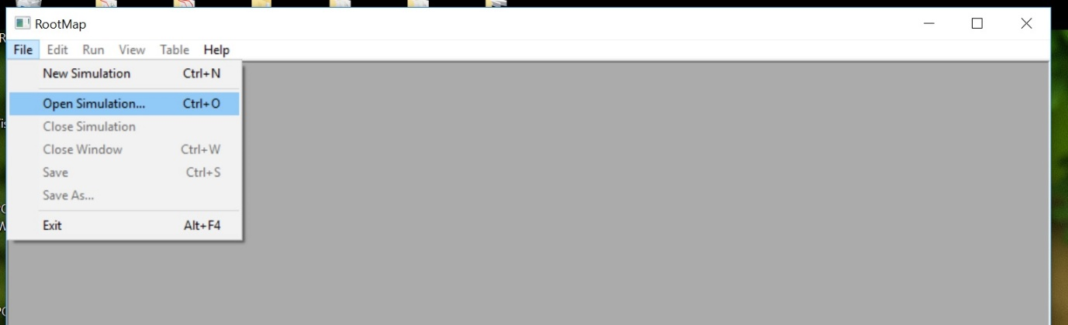

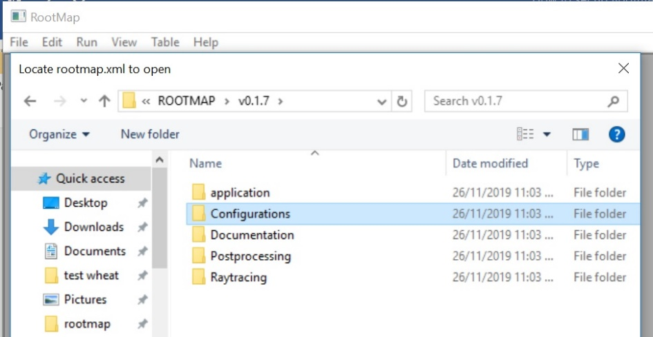An explorer window will open. Look in the Configurations directory. A “default” directory will be present, as well as a “library”. (If the Configurations directory is empty, check that you are in the correct directory for your ROOTMAP version number as in the picture.)

Click into your configuration of choice. In the base directory of the configuration is a file called “rootmap.xml”. Select this and click OK.

The program will take some moments to load the simulation. When it has loaded the simulation, three display windows will open within the main ROOTMAP window – a progress window, a 2D front-view and a 3D view. Move these as you prefer for visibility.

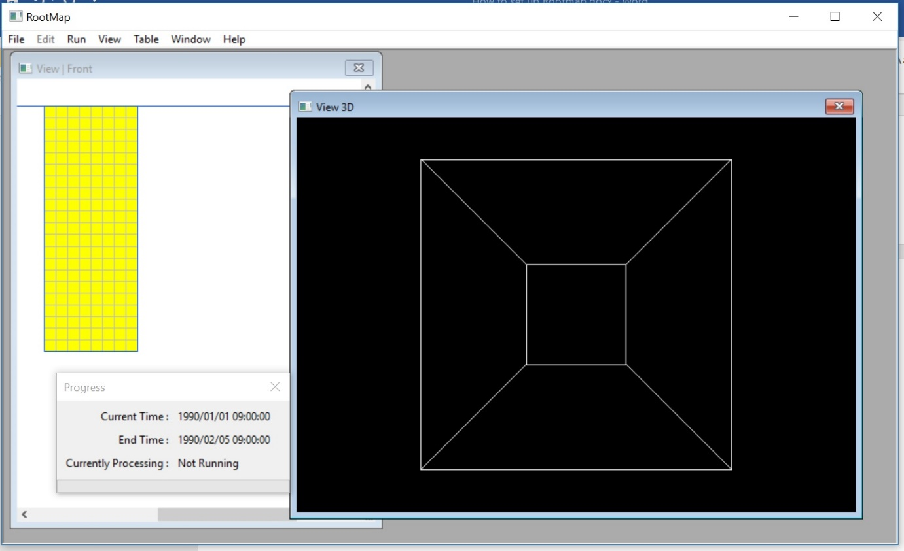

### Running the simulation and adjusting the view windows

To run the simulation you have loaded, click on “Run” and then “Go” as in the picture.

The simulation will begin. It may seem to not be doing much for the first minute or two, as most configurations are set up for plant growth to begin two days after seeding (time zero).

You can adjust your view of the simulation while it is running, if you wish. Click on the window you wish to select to adjust, then click View. You will get a range of options. These do not change the simulation itself, they only change the display. In the 2D window you will find options for a top view, side view and front view (default is front view). You can also change which soil characteristics are displayed with which colour, as in the example below.

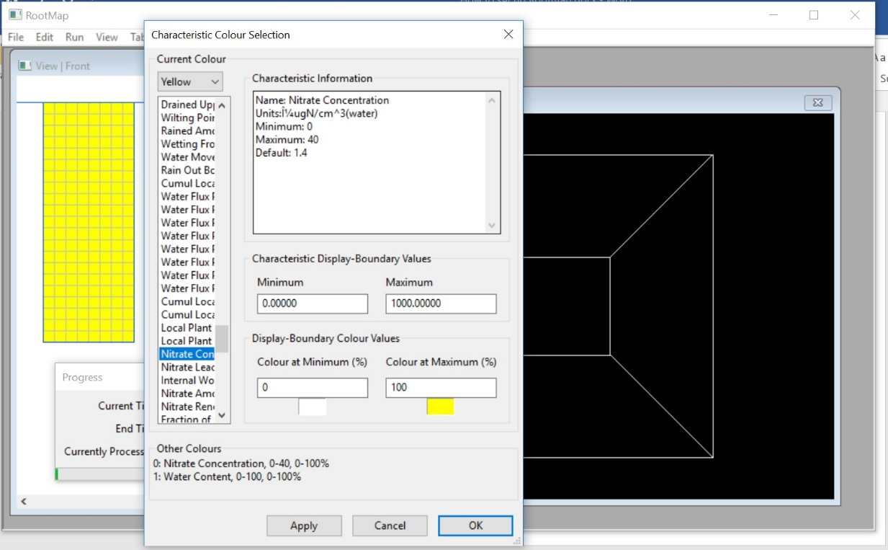

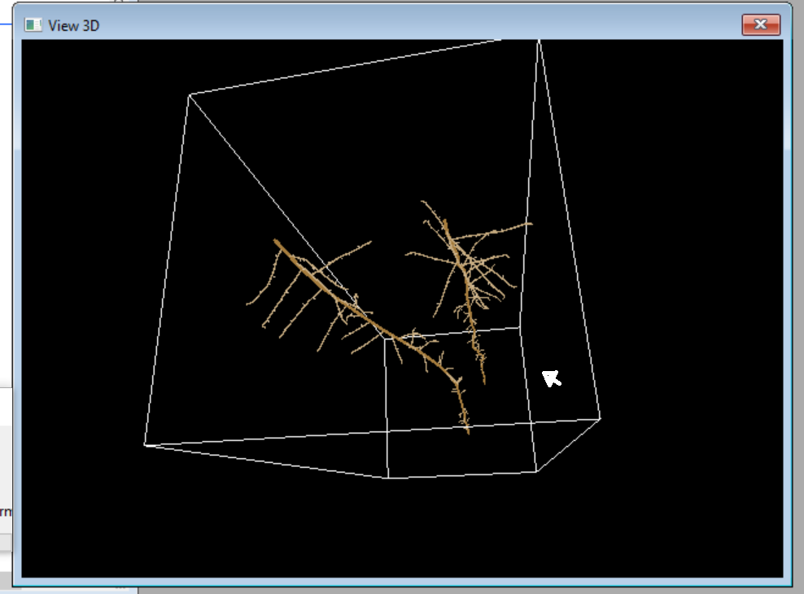You can adjust the angle at which you view the 3D window by clicking and dragging with your left mouse button.

### Capturing and viewing output data

Output files for numeric or raytracing data are defined in the configuration and will always overwrite existing output files. They will remain open for further input until the simulation has been closed either from the ROOTMAP menu or by closing ROOTMAP completely. See the Capturing Output documentation for more details.

### Re-running this or another simulation

Once the simulation has run through, it can be closed using File -> Close Simulation. You can then re-run the same simulation by re-opening it, or run a new simulation by selecting a new set of configuration files (always by choosing the appropriate rootmap.xml file from the File -> Open Simulation menu and loading window.)

Some simulations are set to run identically each time, others will be affected by stochastic randomness and produce similar but non-identical results on subsequent runs.

To develop your own configuration for a simulation run, please see the document “Setting Up A Simulation”.